ASSIGNMENT-2

SHAIK ASHA MUSKAN

E-mail: [ashiasha2409@gmail.com](mailto:ashiasha2409@gmail.com)

Phone No:9346526608

Batch.No:121

Aim: To create one Transit gateway in one region and another in another region and enable communication between both transit gateways.

A transit gateway connects your Amazon Virtual Private Clouds (VPCs) and non-premises network through a central hub. As your cloud infrastructure expands globally, inter-region peering connects transit gateways together using the AWS Global Infrastructure.

Routing is done through a transit gateway operates at layer 3, where the packets sent to a specific next-hop attachment, based on their destination IP addresses.

To do the following process we have to follow some sequence of steps in order to archive the desired outcome.

STEP_1:

Create three different VPC’s

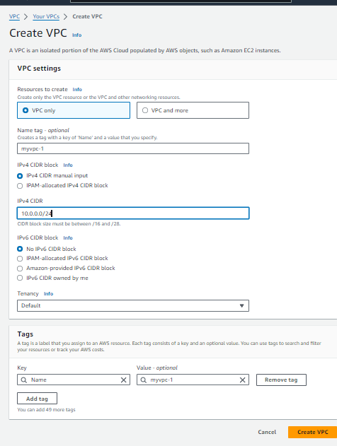

Here we have taken names of VPC’s as

my-vpc-1, my-vpc-2, my-vpc-3 as show below

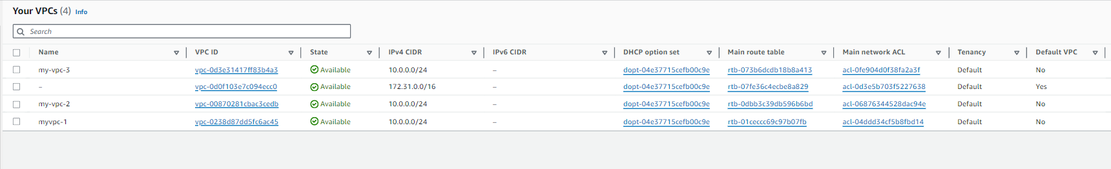

STEP_2:

Create three different subnets for the following VPC’s. provide a different VPC for each subnet with different availability Zones.

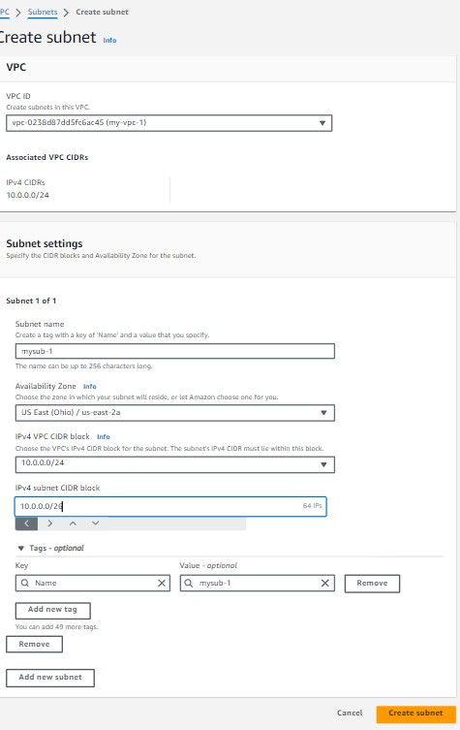

The final outcome after creating different regions is as shown below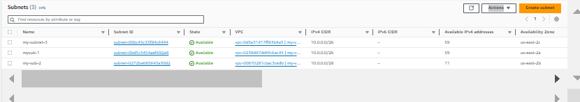

Create three different internet gateways for three different VPC’s

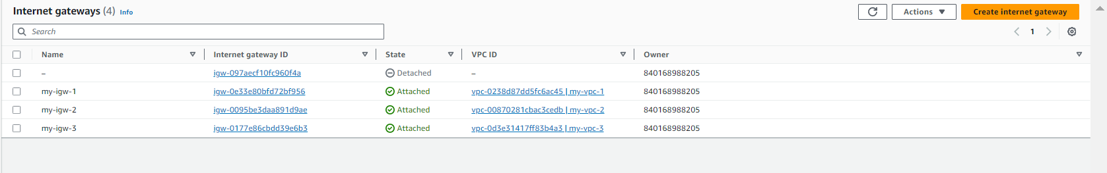

Create the route tables for the following VPC’s we have created earlier and edit subnet associations for the following route tables that we have created

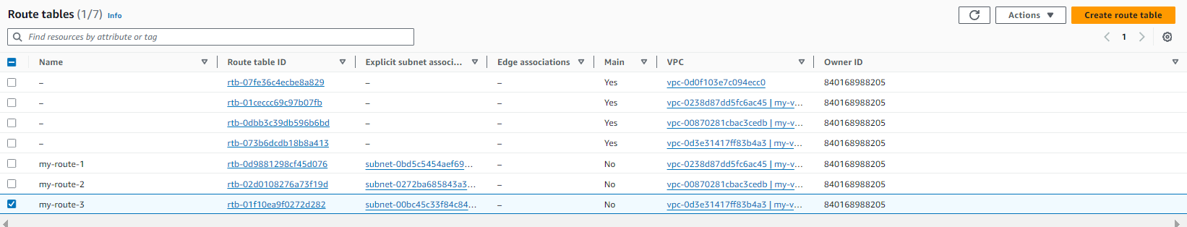

Create a transit gateway



After transit gateway creation we have to attach internet gateways

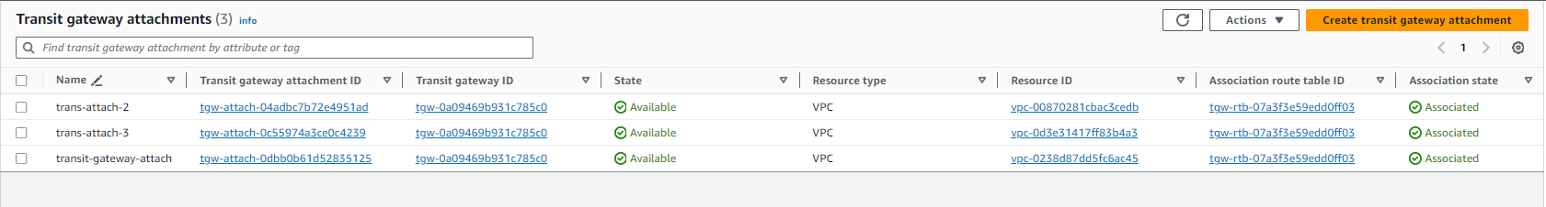

Now create an EC2 instance in the same region by attaching the AMI, Key Pair and network setting

Add the Http in the inbound rules to the security groups

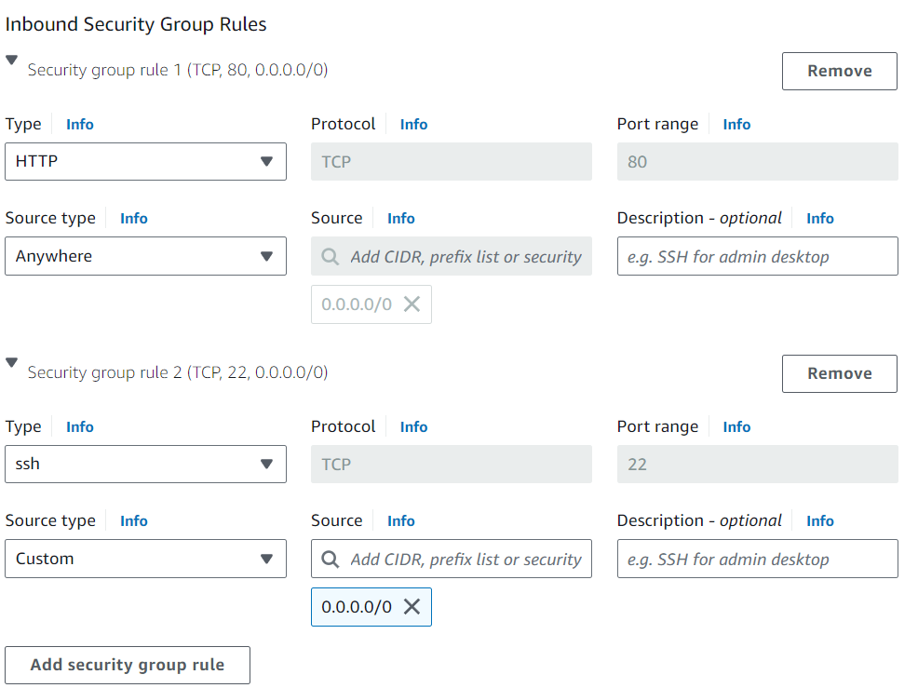

Launch the instance in the web

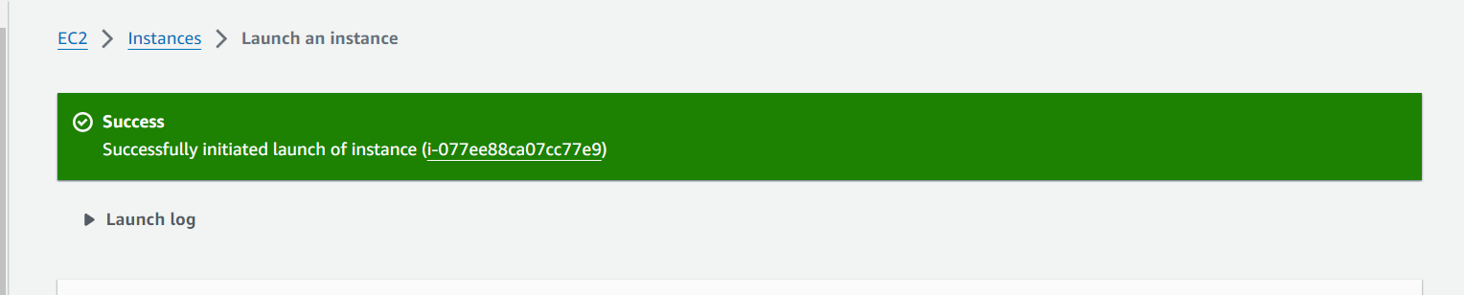

Do the following task

1. Sudo -i to connect to the root user
2. Yum update -y to update application packages
3. ) Yum install nginx -y to install the nginx (proxy server) in amazon Linux distribution,
4. ) Then remove index.html by moving into the default directory cd /usr/share/nginx/html and create a html file by index.html with a certain data,
5. ) Systemctl status nginx to check the nginx is active or dead, 6) Curl private IP:80 to see the content of respective IP.

Now create a transmit gateway ● Attach the transit gateway with the VPC in the given region

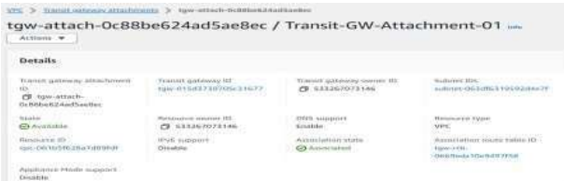

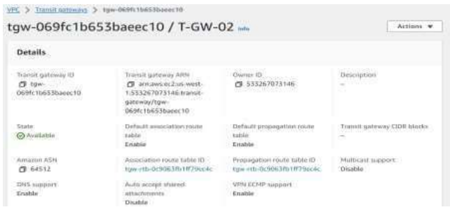

Now go to the route tables in the VPC and click on edit route add the Transit gateway and click on save changes.

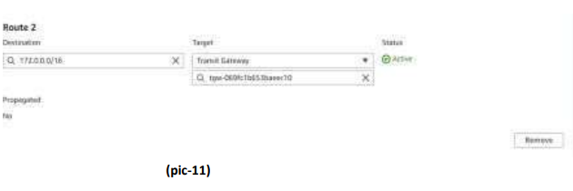

This is the First instance

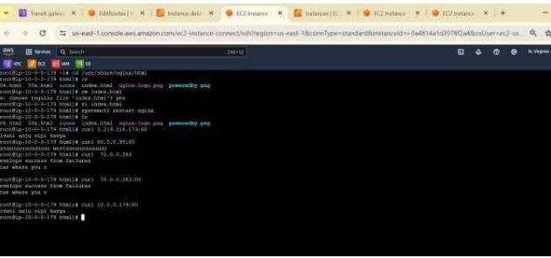

This is the Second Instance:

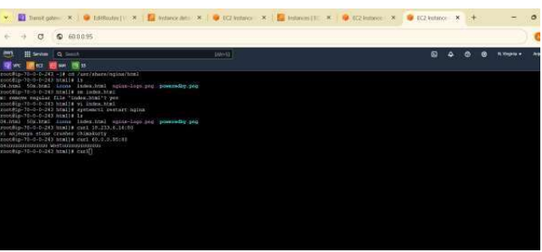

This is my third instance

